NOM:

4 | X | 0 | = | 0
4 | X | 1 | =
 |  |  | =
 |  |  | =
 |  |  | =
 |  |  | =
 |  |  | =
 |  |  | =
 |  |  | =
 |  |  | =
 |  |  | =

5 | X | 0 | = | 0
5 | X | 1 | =
 |  |  | =
 |  |  | =
 |  |  | =
 |  |  | =
 |  |  | =
 |  |  | =
 |  |  | =
 |  |  | =
 |  |  | =

6 | X | 0 | = | 0
6 | X | 1 | =
 |  |  | =
 |  |  | =
 |  |  | =
 |  |  | =
 |  |  | =
 |  |  | =
 |  |  | =
 |  |  | =
 |  |  | =

https://wordwall.net/play/883/144/192
7 | X | 0 | = | 0
7 | X | 1 | =
 |  |  | =
 |  |  | =
 |  |  | =
 |  |  | =
 |  |  | =
 |  |  | =
 |  |  | =
 |  |  | =
 |  |  | =

8 | X | 0 | = | 0
8 | X | 1 | =
 |  |  | =
 |  |  | =
 |  |  | =
 |  |  | =
 |  |  | =
 |  |  | =
 |  |  | =
 |  |  | =
 |  |  | =

11 | X | 0 | = | 0
11 | X | 1 | =
 |  |  | =
 |  |  | =
 |  |  | =
 |  |  | =
 |  |  | =
 |  |  | =
 |  |  | =
 |  |  | =
 |  |  | =

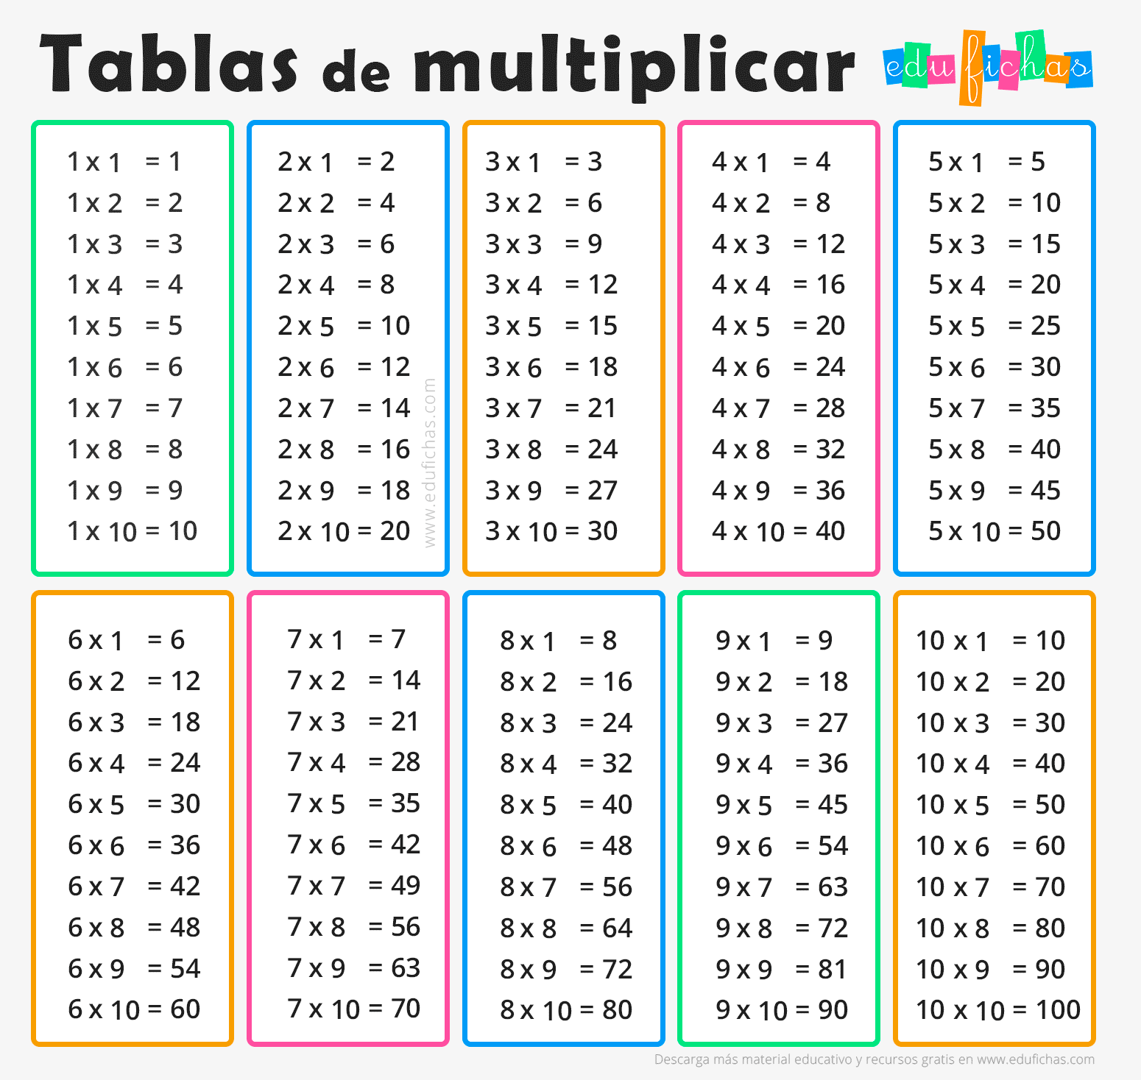

Realitza aquestes divisions:
https://www.thatquiz.org/tq-1/?-j4g08-la-mpnv600-p0
https://wordwall.net/es/resource/24379676

