AVUI TREBALLAREM MESURES:
1.- https://www.thatquiz.org/es-9/?-j1-l2-mpnv600-nk-ppnv600
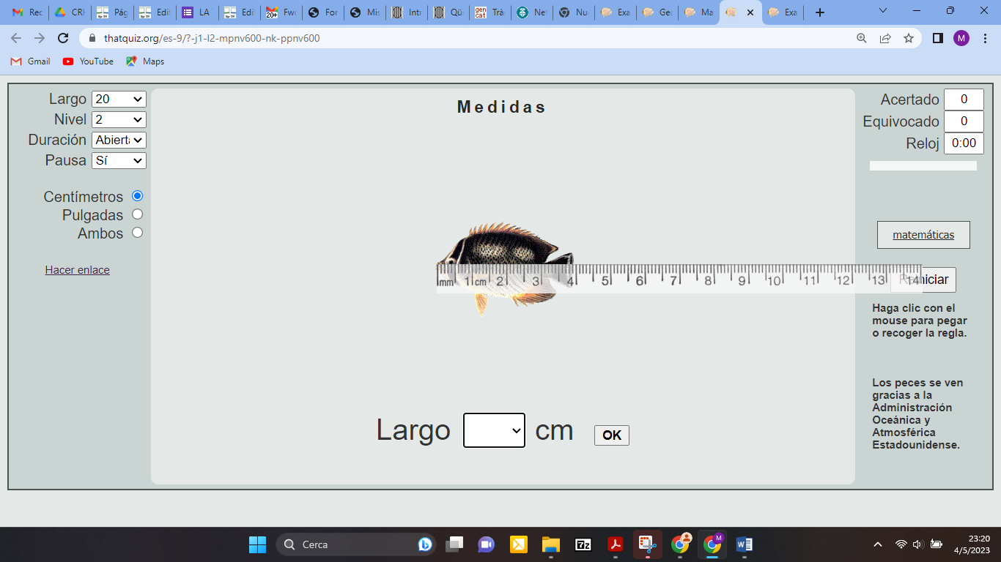
2.- https://www.thatquiz.org/es-6/?-j4-l9-mpnv600-nk-ppnv600
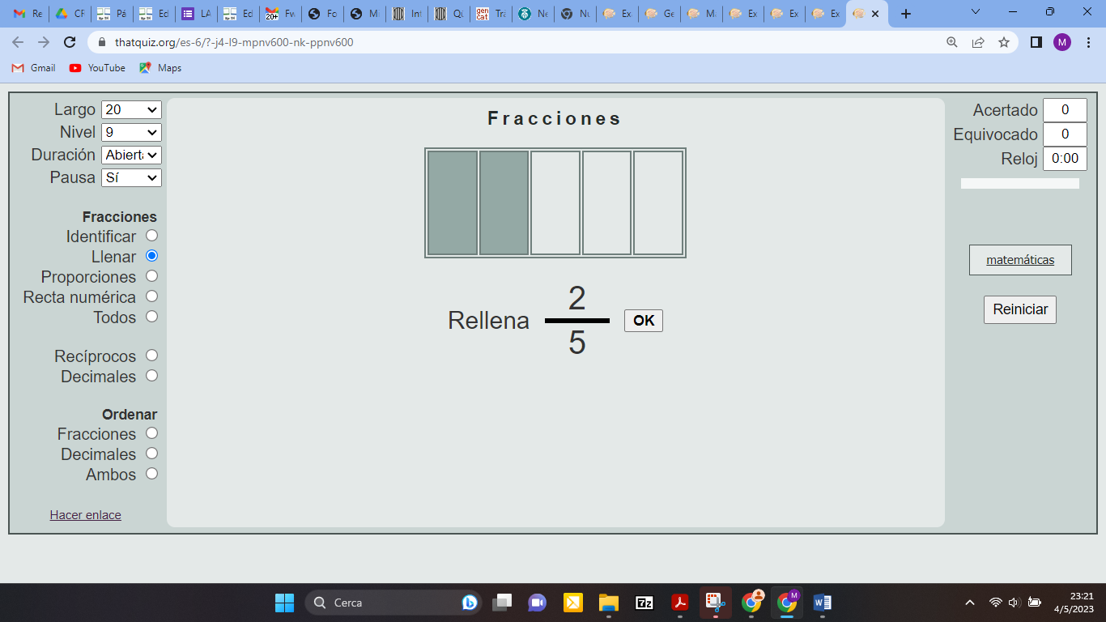
3.- https://www.thatquiz.org/es-5/?-j1000h-l1-mpnv600-ppnv600
