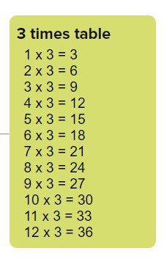
Realitza aquest exercici de la taula del 2
1 x 3 =
2 x 3 =
3 x 3 =
4 x 3 =
5 x 3 =
6 x 3 =
7 x 3 =
8 x 3 =
9 x 3 =
10 x 3 =
11 x 3 =
12 x 3 =

Pinta els quadres que tenen resultats de la taula del 2.

12 | 7 | 16 | 28 | 3
36 | 30 | 36 | 38 | 21
18 | 33 | 2 | 22 | 8
4 | 30 | 29 | 3 | 36
9 | 33 | 11 | 1 | 25

4 x 3 =
6 x 3 =
7 x 3 =
2 x 3 =
9 x 3 =
3 x 3 =
11 x 3 =
1 x 3 =
5 x 3 =
10 x 3 =
8 x 3 =
12 x 3 =
6 x 3 =
1 x 3 =
9 x 3 =
10 x 3 =
7 x 3 =
11 x 3 =
3 x 3 =

I aquest joc:
https://wordwall.net/resource/13999298

