[KODABLE 4T](https://game.kodable.com/class/88xpnhf)

1.-

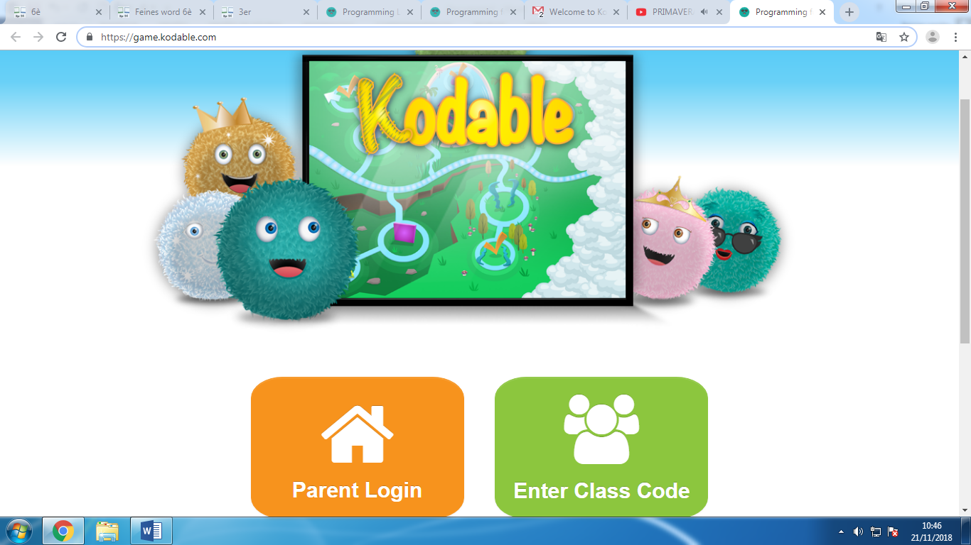

2.-

