Numeració:

|  |  |
| --- | --- |
|  |  |
|  |  |
|  |  |



|  |  |  |  |  |
| --- | --- | --- | --- | --- |
|  |  |  |  |  |

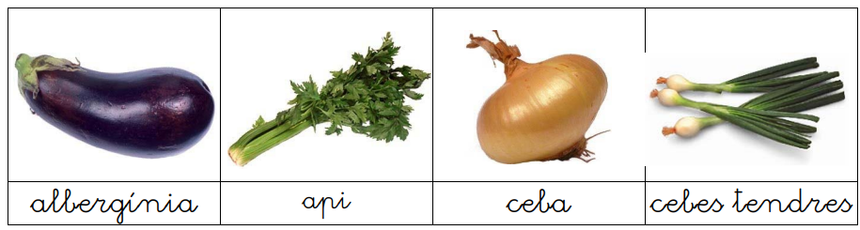

|  |  |  |  |
| --- | --- | --- | --- |
|  |  |  |  |

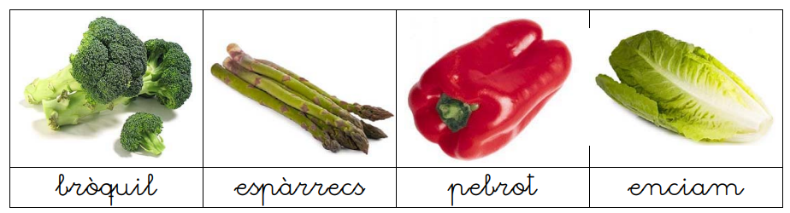

|  |  |  |  |
| --- | --- | --- | --- |
|  |  |  |  |

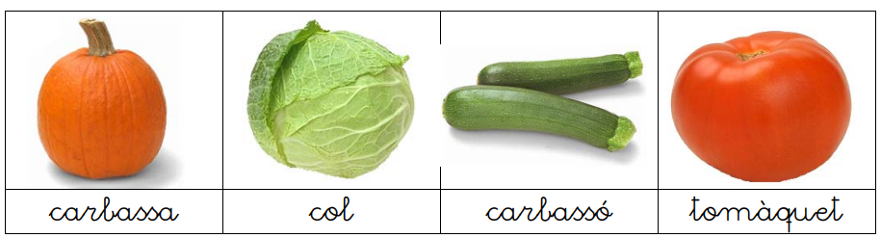

|  |  |  |  |
| --- | --- | --- | --- |
|  |  |  |  |

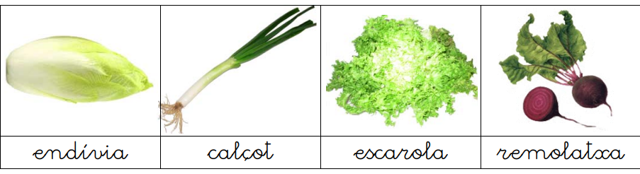

|  |  |  |  |
| --- | --- | --- | --- |
|  |  |  |  |

Busca a google

|  |  |
| --- | --- |
| AUTOCARAVANA |  |
| COTXE FAMILIAR |  |
| CAMIÓ |  |
| TENDA DE CAMPING |  |
| FURGONETA |  |