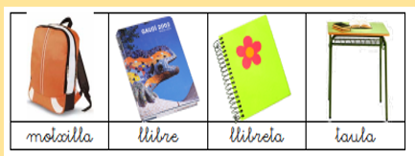

|  |  |  |  |
| --- | --- | --- | --- |
| **motxilla** |  |  |  |

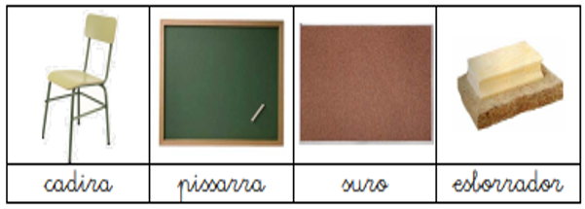

|  |  |  |  |
| --- | --- | --- | --- |
|  |  |  |  |

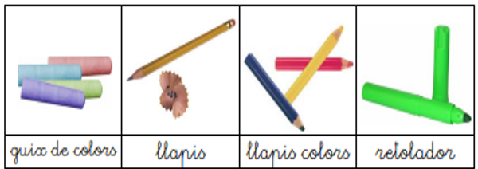

|  |  |  |  |
| --- | --- | --- | --- |
|  |  |  |  |

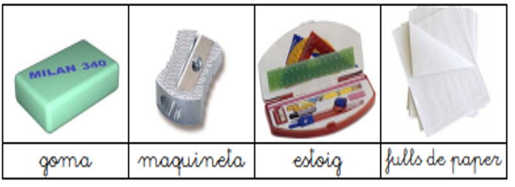

|  |  |  |  |
| --- | --- | --- | --- |
|  |  |  |  |

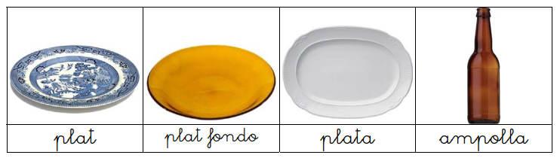

|  |  |  |  |
| --- | --- | --- | --- |
|  |  |  |  |

<https://wordwall.net/play/1586/645/378>