FRACCIONES

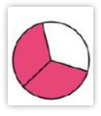 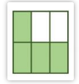  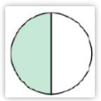 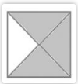

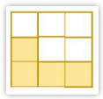 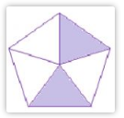  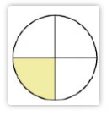 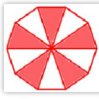

|  |  |  |  |  |
| --- | --- | --- | --- | --- |
| 3/6 | 4/6 | 4/9 | 2/5 | 1/3 |
|  |  |  |  |  |
|  |  |  |  |  |
| ¾ | ½ | 2/3 | ¼ | 5/10 |

Busca:

|  |  |
| --- | --- |
| Fracció | foto |
| ¼ |  |
| 1/3 |  |
| 2/3 |  |
| 2/5 |  |

1.- <https://wordwall.net/play/3734/650/2300>

2.- <https://wordwall.net/play/17578/308/803>

2.- <https://wordwall.net/play/2562/035/73420>