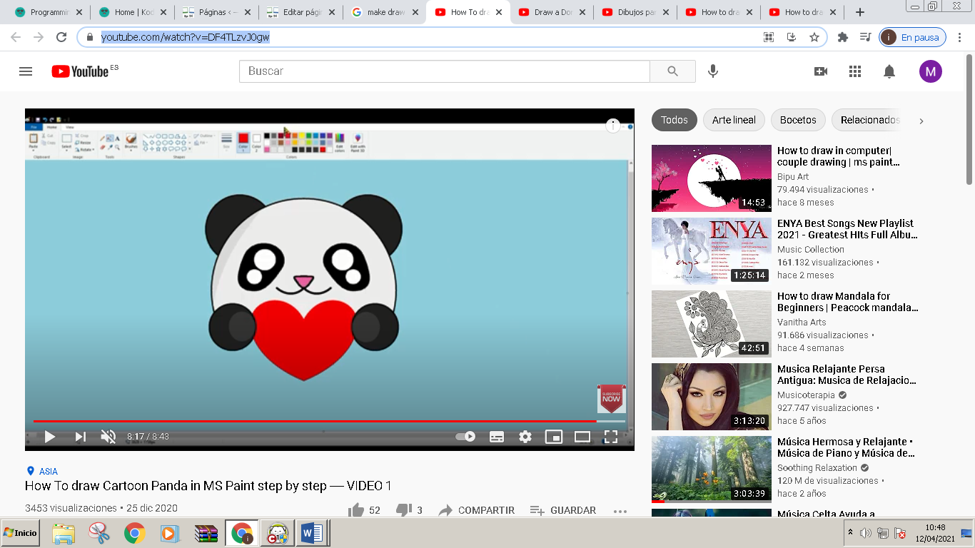
https://www.youtube.com/watch?v=DF4TLzvJ0gw

