PRACTICA L’ABECEDARI
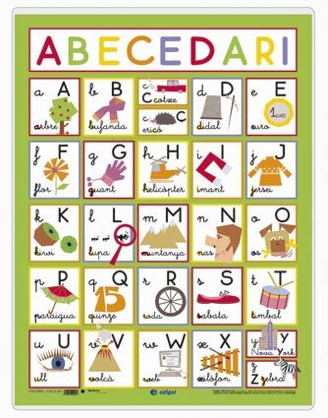
Ordena les paraules
DEMÀ
AIGUA
BOL
CAMELL
ELEFANT

https://clic.xtec.cat/projects/alfabet2/jclic.js/index.html

http://lasenalla.net/arxius/abc2/abc2.html

