CONCURS
TAULA DE L’5 |  | TAULA DEL 4 |  | TAULA DEL 5
3 X 0 |  | 4 X 0 |  | 5 X 0
3 X 1 |  | 4 X 1 |  | 5 X 1
3 X 2 |  | 4 X 2 |  | 5 X 2
3 X 3 |  | 4 X 3 |  | 5 X 3
3 X 4 |  | 4 X 4 |  | 5 X 4
3 X 5 |  | 4 X 5 |  | 5 X 5
3 X 6 |  | 4 X 6 |  | 5 X 6
3 X 7 |  | 4 X 7 |  | 5 X 7
3 X 8 |  | 4 X 8 |  | 5 X 8
3 X 9 |  | 4 X 9 |  | 5 X 9
3 X10 |  | 4 X10 |  | 5 X10

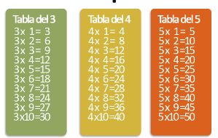
JOC
https://wordwall.net/play/665/892/370

