REALITZA AQUESTS JOCS
1.- https://www.starfall.com/h/math2/
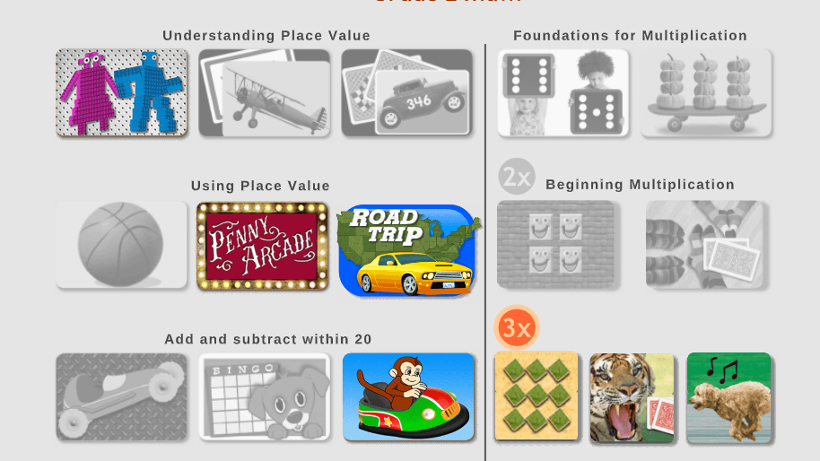

2.- https://www.starfall.com/h/math2/

