EXERCICIS D’HORES, MESURES I FRACCIONS.
QUAN ACABIS ENGANZA EL QUADRE

- https://www.thatquiz.org/tq-g/?-j1-l2-mpnv600-p0

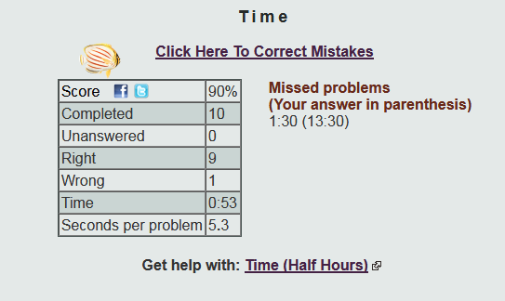

- https://www.thatquiz.org/tq-A/?-j2-l4-m1s-ppnv600
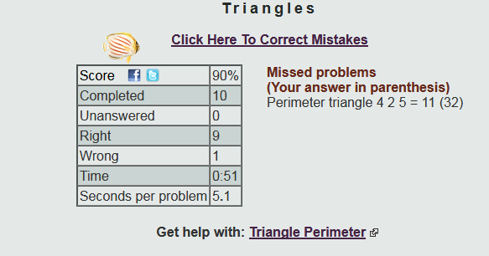

- https://www.thatquiz.org/tq-6/?-j4-l5-mu-ppnv600

