1.-SIMETRIES
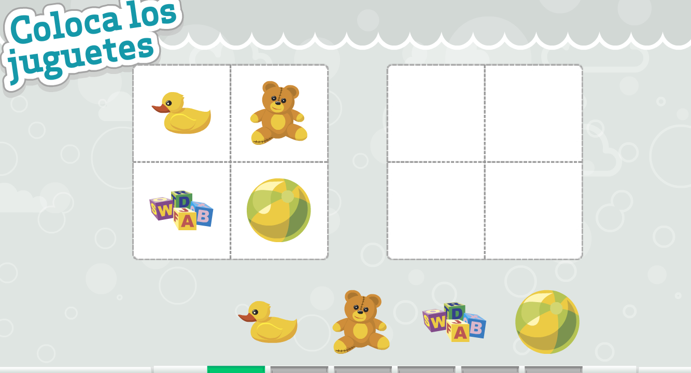

http://www.educa.jcyl.es/educacyl/cm/gallery/Recursos%20Infinity/aplicaciones/cabania_divertida/applications/app3/app3.htm

2.-ORDENA CORRECTAMENT

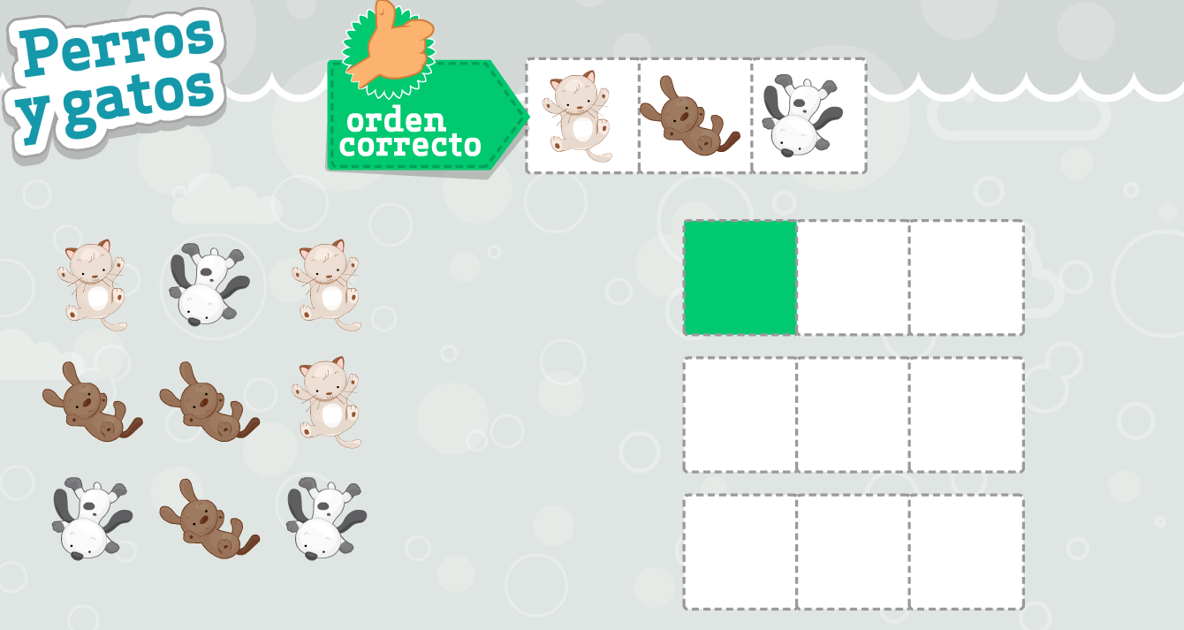

http://www.educa.jcyl.es/educacyl/cm/gallery/Recursos%20Infinity/aplicaciones/cabania_divertida/applications/app1/app1.htm

