Taula 1  1 × 0 = 0  1 × 1 =  1 × 2 =  1 × 3 =  1 × 4 =  1 × 5 =  1 × 6 =  1 × 7 =  1 × 8 =  1 × 9 =  1 × 10 =  1 × 11 =  1 × 12 = | Taula del 2  2 × 0 = 0  2 × 1 =  2 × 2 =  2 × 3 =  2 × 4 =  2 × 5 =  2 × 6 =  2 × 7 =  2 × 8 =  2 × 9 =  2 × 10 =  2 × 11 =  2 × 12 = | Taula del 3  3 × 0 = 0  3 × 1 =  3 × 2 =  3 × 3 =  3 × 4 =  3 × 5 =  3 × 6 =  3 × 7 =  3 × 8 =  3 × 9 =  3 × 10 =  3 × 11 =  3 × 12 = | Taula del 4  4 × 0 = 0  4 × 1 =  4 × 2 =  4 × 3 =  4 × 4 =  4 × 5 =  4 × 6 =  4 × 7 =  4 × 8 =  4 × 9 =  4 × 10 =  4 × 11 =  4 × 12 = | Taula del 5  5 × 0 =  5 × 1 =  5 × 2 =  5 × 3 =  5 × 4 =  5 × 5 =  5 × 6 =  5 × 7 =  5 × 8 =  5 × 9 =  5 × 10 =  5 × 11 =  5 × 12 =

CONCURS
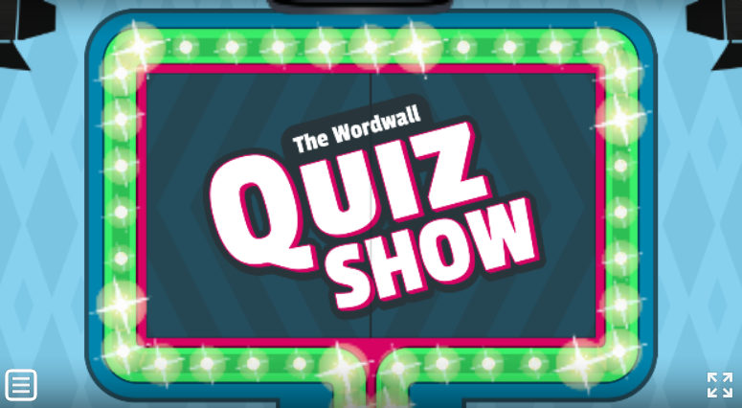
https://wordwall.net/play/427/975/238

