CONTROL DE RATOLÍ

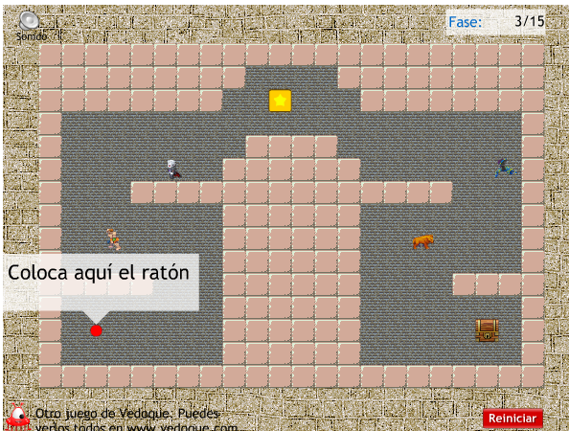
https://www.vedoque.com/juegos/juego.php?j=laberinto-raton&l=es

https://wordwall.net/play/426/994/388

