KAHOOT

MULTIPLICACIONS

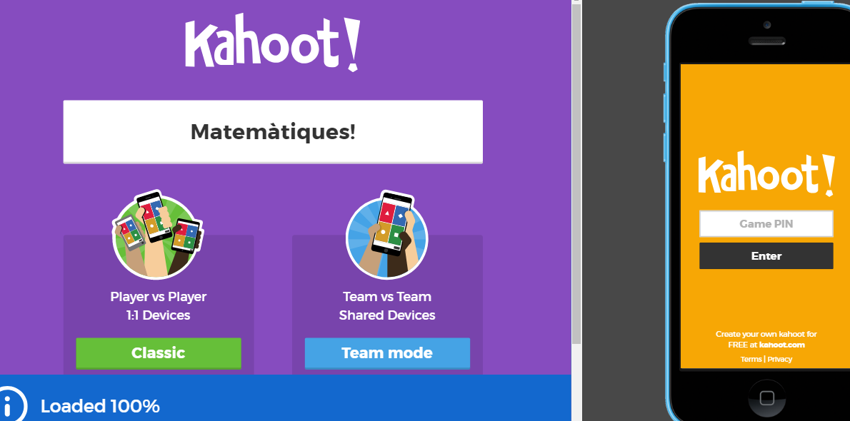

1.-
https://create.kahoot.it/l/#/preview/f5022c7f-49ce-4bad-8b93-b9e9887d1951

2.-
https://create.kahoot.it/l/#/preview/f597afe7-e100-45f1-b615-50f9af1dc4bf

3.-
https://create.kahoot.it/l/#/preview/96e0de47-ef19-45c7-b39a-cf0798b49df4

