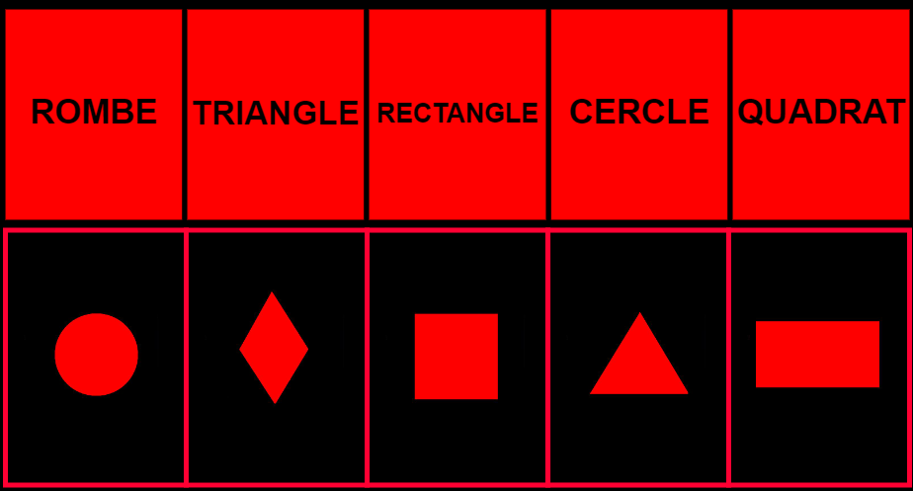

ROMBE
TRIANGLE
RECTANGLE
CERCLE
QUADRAT

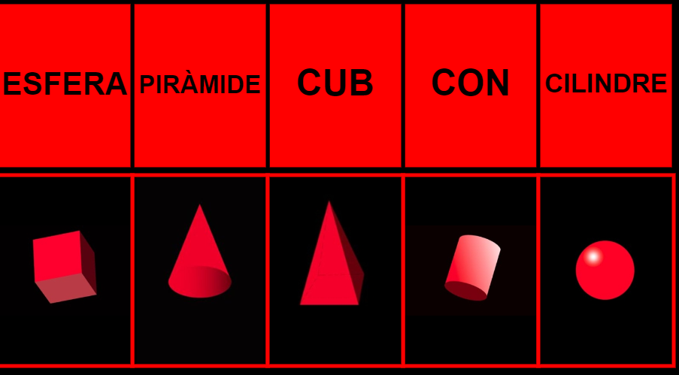
ESFERA
PIRÀMIDE
CUB
CON
CILINDRE

https://clic.xtec.cat/projects/geomet3/jclic.js/index.html

