COMARQUES COSTERES DE CATALUNYA

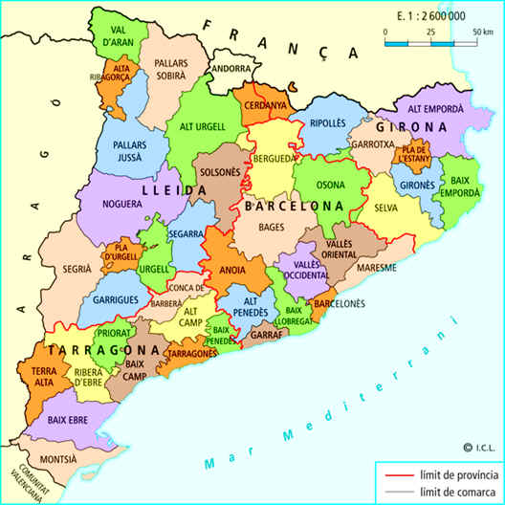

Escriu les 12 comarques costeres de Catalunya:

|  |  |  |
| --- | --- | --- |
| MONTSIÀ | BAIX EBRE |  |
|  |  |  |
|  |  |  |
|  |  |  |

Joc:

<https://wordwall.co.uk/resource/213644>