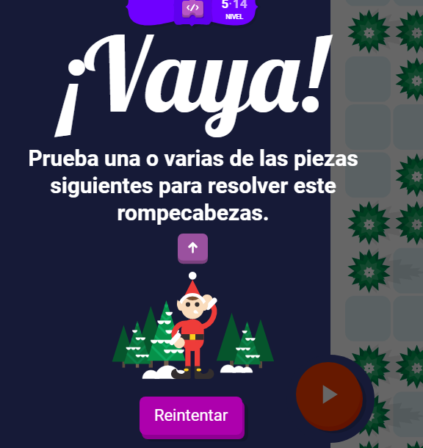

https://santatracker.google.com/intl/es/codelab.html

