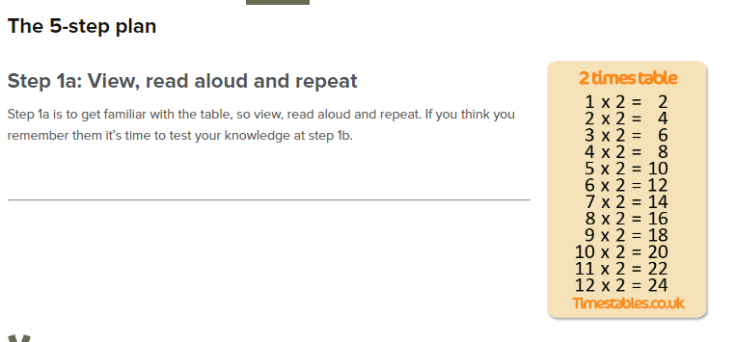
Realitza aquest exercici de la taula del 2
https://www.timestables.co.uk/2-times-table.html

I aquest joc:
https://wordwall.net/resource/320639

