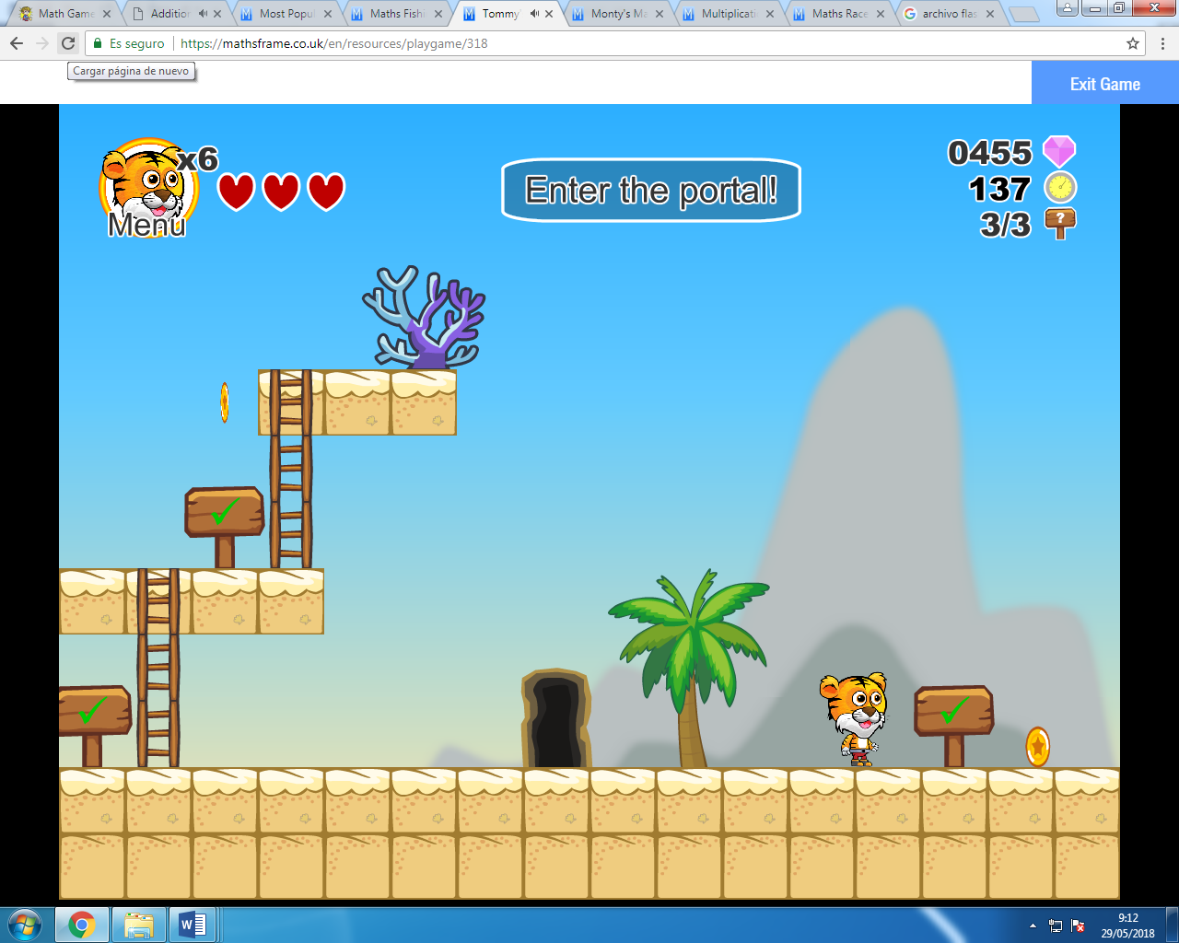

https://mathsframe.co.uk/en/resources/playgame/318

