Nom: Data:

ORDENA LAS PALABRAS

|  |  |  |
| --- | --- | --- |
| N L O E A | S M A E | A L P A |
| leona | mesa | pala_1 |
|  |  |  |

|  |  |  |
| --- | --- | --- |
| P L A U | O N M O | E N P I E |
| lupa | mono | peine |
|  |  |  |

|  |  |  |
| --- | --- | --- |
| N M O A | A S P O | A M U S |
| mano derecha | sopa | 3 + 2 |
|  |  |  |

|  |  |  |
| --- | --- | --- |
| M L A I | A P M L A O | O P L E |
| thumbnail | paloma | pelo |
|  |  |  |

[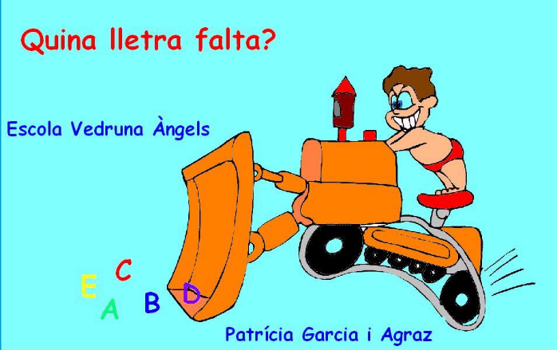](http://www.vedruna-angels.org/vangels/antiga/clicsprim/1/catala/lletrafalta/index.html)

<http://www.vedruna-angels.org/vangels/antiga/clicsprim/1/catala/lletrafalta/index.html>