Nom:

Data:

Compta quants n’hi ha:

|  |  |  |
| --- | --- | --- |
|  |  |  |
|  |  |  |
|  |  |  |
|  |  |  |
|  |  |  |
|  |  |  |

Resta:

|  |  |  |
| --- | --- | --- |
|  |  |  |
| 8 – 4 = | 9 – 6 = | 7 – 2 = |
|  |  |  |
| 6 – 6 = | 7 – 0 = | 6 – 1 = |

|  |  |  |
| --- | --- | --- |
| 21 | 22 |  |

|  |  |  |
| --- | --- | --- |
| 34 | 35 |  |

|  |  |  |
| --- | --- | --- |
| 14 |  | 16 |

|  |  |  |
| --- | --- | --- |
| 39 |  | 41 |

Completa:

Fes grups de 10 i completa:

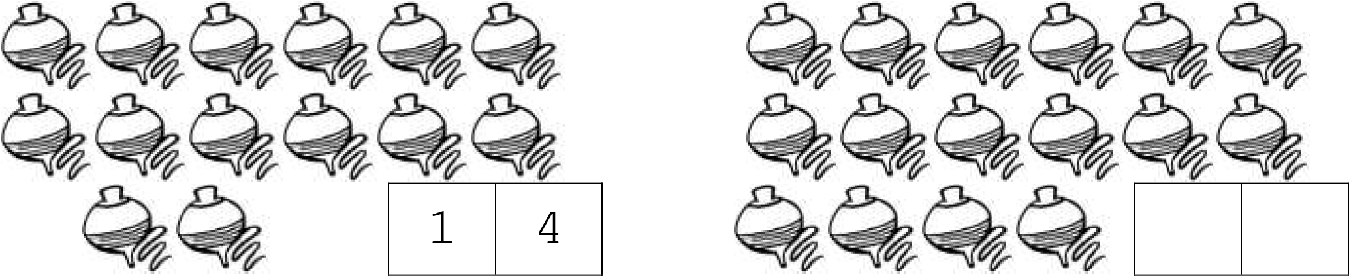

JOC:

<https://wordwall.co.uk/resource/191991/control-3r>