Calcula:
80€
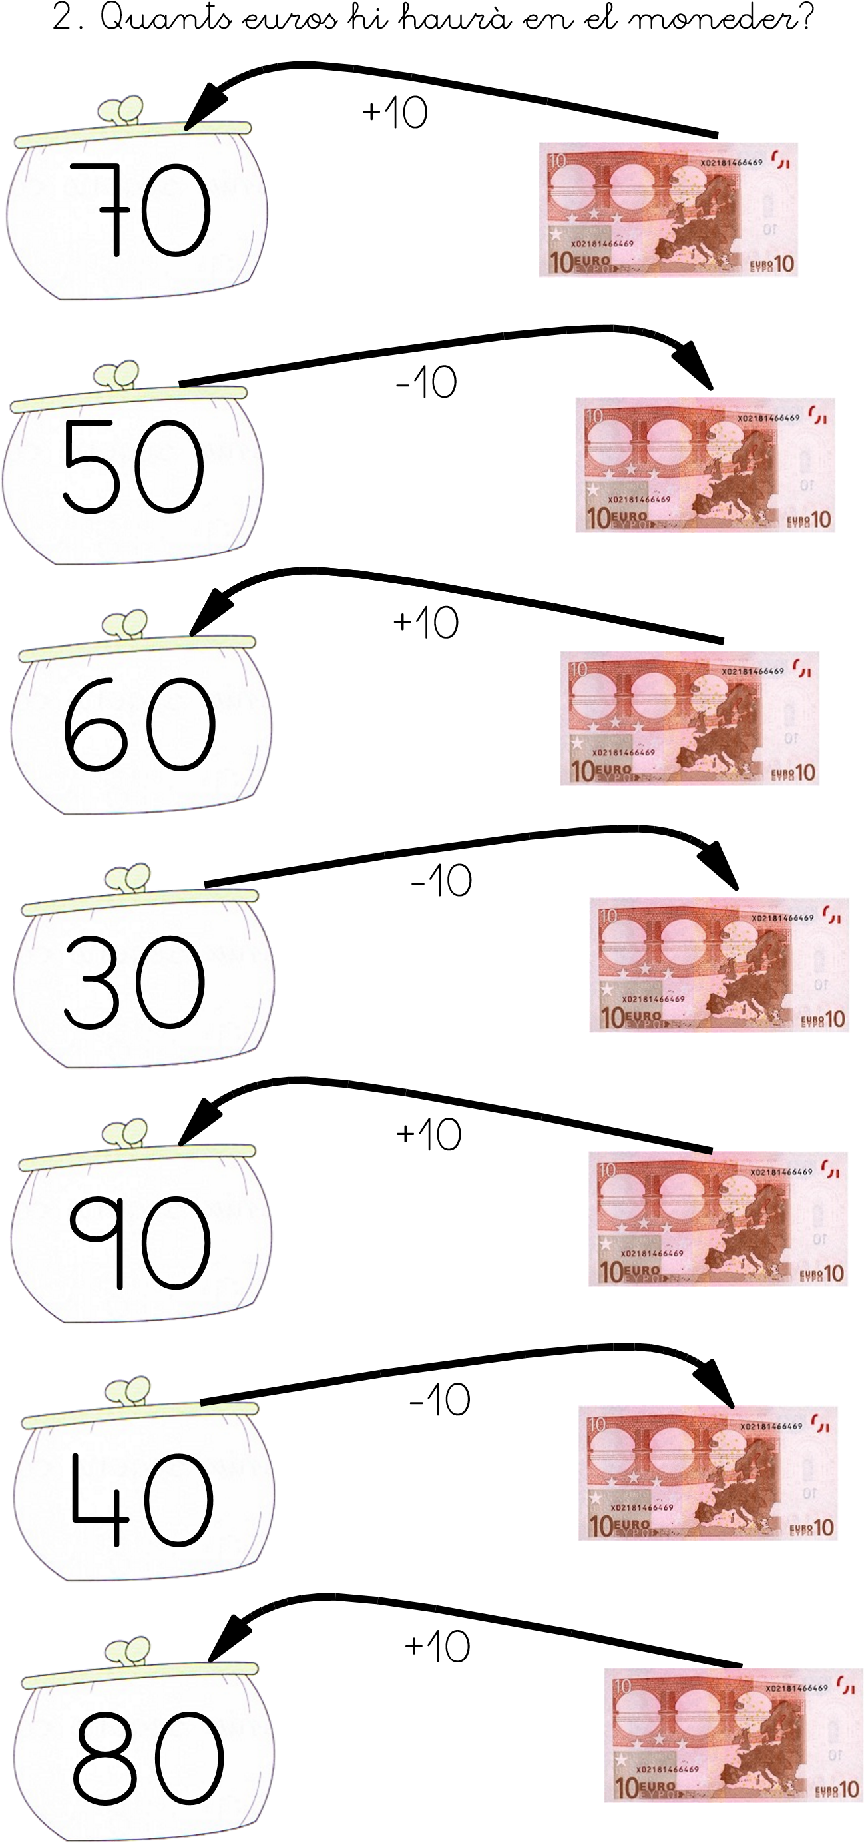

Calcula:

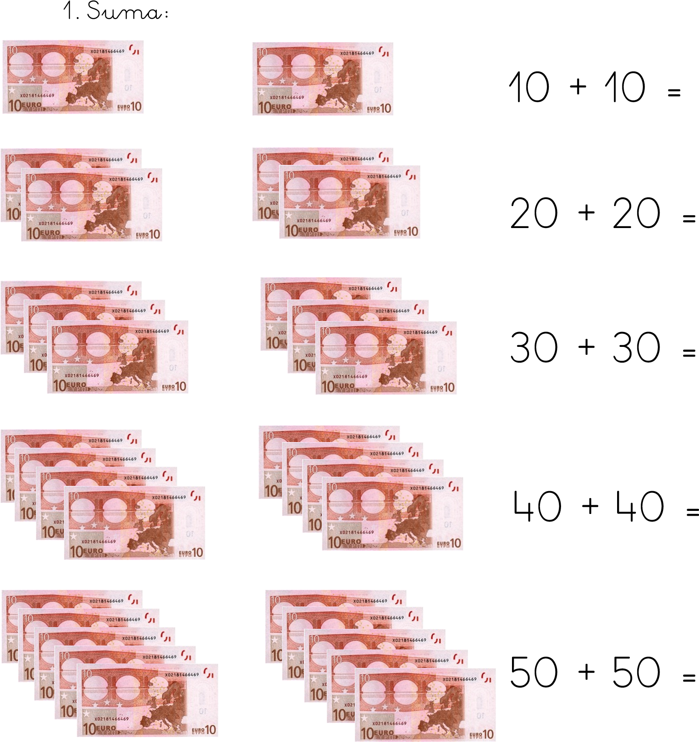

JOC d’Euros:
https://www.thatquiz.org/es/practice.html?money

