Realitza aquesta enquesta:

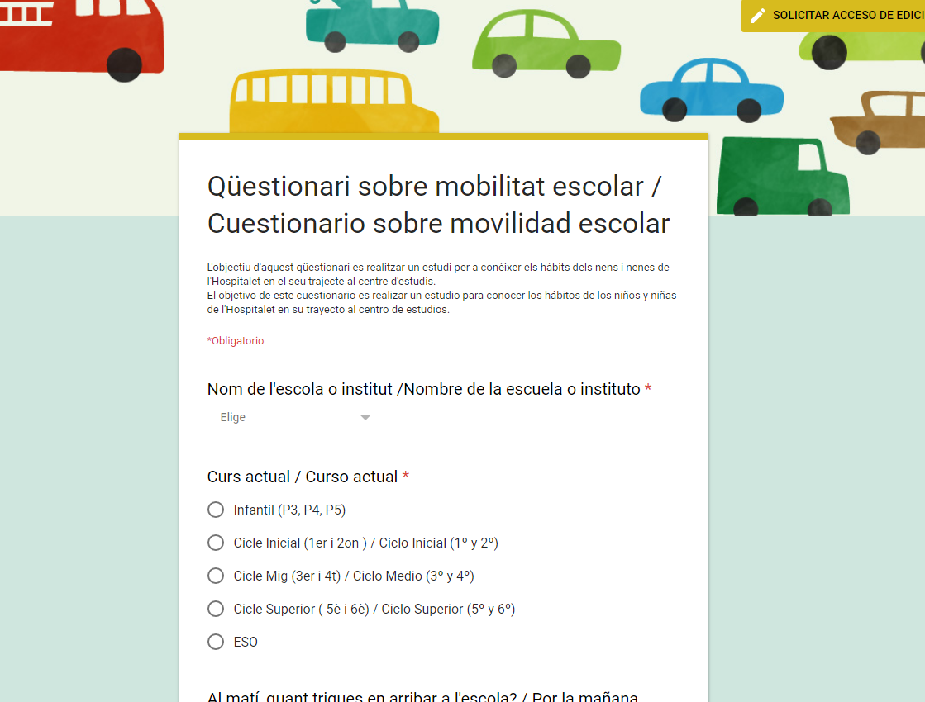

https://docs.google.com/forms/d/1nGaeWaIWVuQXXARNa7St-eYrfbLJ8OindFovBmCQMAg/viewform?chromeless=1&edit_requested=true

